**MIRACLE SAINTS JUNIOR SCHOOL NKUMBA**

**MID TERM II ASSESSMENT 2024**

**TOP CLASS: (5 – 6 YEARS)**

**LEARNING AREA 2: LANGUAGE DEVELOPMENT 1**

**My name is: ………………………………..………………………….**

**My School is: ……………………………..……….…………………..**

**I am in: ………………………………..…………………………………………..**

1. 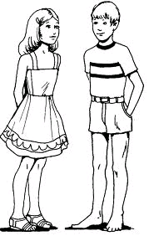**Name the pictures.**



**_____________ ______________**

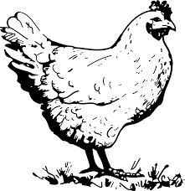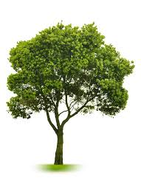

**________ ____________**

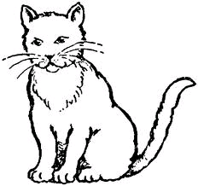

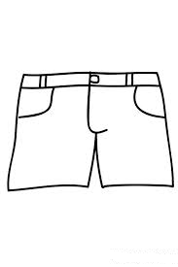

**___________ ____________**

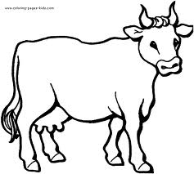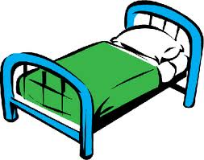

**____________ _________**

1. **Read and draw the picture**

|  |  |  |
| --- | --- | --- |
| **a box** | **a car** | **a rat** |
|  |  |  |
| **a table** | **a fan** | **a hat** |
|  |  |  |

1. 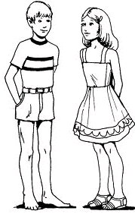**Match and write the word.**

**cat _____________**



**bed ______________**

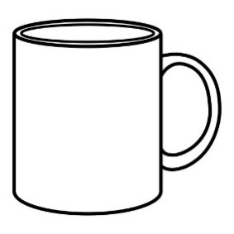

**boy _______________**

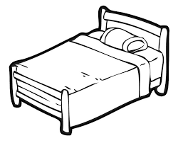

**bag _______________**



**cup ________________**

1. **Write the missing letters.**

**a _____ _____ _____ _____ _____ g _____ i _____ _____ l _____ _____ o _____ _____ r _____ _____ _____ v _____ _____ _____ z**

1. **Fill in the missing letter.**

**b___ok**

**b___g**

**h____use**

**p____t**

**END**